### ABSTRACT

Recent advances in technology have brought with them precious solutions to en- hance communication for deaf or mute people. This research aims to enhance com- munication for such people by adopting an automatic speech system. Communica- tion is a basic part of human behavior, and it plays an important role in the way we connect with others. Just imagine how difficult it would be if humans could not speak or hear! The main drive of this project is to aid those who encounter such difficulties by facilitating better interaction with others. Since sign language is not necessarily spoken by everyone everywhere, the system facilitates the disabled to communicate well so that they can express their ideas and requirements. The system has huge potential to contribute to industries like healthcare and education.

Wearable gloves are utilized here as a cheap alternative. There are four flex sen- sors, one accelerometer, one speaker module, gloves, one Arduino Uno microcon- troller, an LCD screen, a GSM 800L module, and one lithium-ion rechargeable bat- tery employed in this system. These create an intelligent sign language acknowl- edgement system for the support of people who are mute. The system employs three rechargeable batteries to supply power to the Arduino Uno, GSM, and speaker mod- ule. The sensors pick up the movement upon a gesture and transform it into a voltage signal. The Arduino Uno processes the signal and displays the respective sign on the LCD screen and verbally speaks out the identified sign via the speaker.

**Keywords:** Flex Sensors, Wearable Glove, Arduino Uno Hand gesture recognition, Sign language translation, Wearable Glove Technology, Real-Time Data Processing, Sensor-Based Input, American Sign Language (ASL),

## LIST OF FIGURES

* 1. Innovation Hand Gesture Communication Architecture 17
  2. Data flow diagram for Hand Gesture Communication progression 18
  3. Use case diagram for Hand Gesture Communication progression 19
  4. Class diagram for Hand Gesture Communication progression 20
  5. Sequence diagram for Hand Gesture Communication progression 21
  6. Collaboration diagram for Gesture Communication progression 22
  7. Activity diagram for Hand Gesture Communication progression 23
  8. Input design of Hand Gesture Communication 32
  9. Output design of Hand Gesture Communication 33
  10. Unit testing result 34
  11. Integration testing result 35
  12. Input images of the Hand Gesture Communication 37
  13. System testing result 37
  14. Testing Image 38

6.1 Comparative Analysis for Gesture Communication 40

6.2 Graphical Analysis for Gesture Communication 41

# LIST OF TABLES

* 1. Comparative Analysis-Tables

# LIST OF ACRONYMS AND ABBREVIATIONS

ASL American Sign Language CNN Convolutional Neural Network DL Deep Learning

IDE Integrated Development Environment IOT Internet of Things

LCD Liquid Crystal Display

ML Machine Learning

PCB Printed Circuit Board

RNN Recurrent Neural Networks SVM Support Vector Machine

UART Universal Asynchronous Receiver Transmitter

# TABLE OF CONTENTS

**Page.No**

ABSTRACT 7

LIST OF FIGURES 8

LIST OF TABLES 9

LIST OF ACRONYMS AND ABBREVIATIONS 10

1. INTRODUCTION 1
   1. Introduction . . . . . . . . . . . . . . . . . . . . . . . . . . . . . . 1
   2. Background . . . . . . . . . . . . . . . . . . . . . . . . . . . . . . 2
   3. Objective . . . . . . . . . . . . . . . . . . . . . . . . . . . . . . . 3
   4. Problem Statement . . . . . . . . . . . . . . . . . . . . . . . . . . 4
2. LITERATURE REVIEW 5
   1. Existing System . . . . . . . . . . . . . . . . . . . . . . . . . . . . 7
   2. Related Work . . . . . . . . . . . . . . . . . . . . . . . . . . . . . 8
   3. Research Gap . . . . . . . . . . . . . . . . . . . . . . . . . . . . . 8
3. PROJECT DESCRIPTION 9
   1. Existing System . . . . . . . . . . . . . . . . . . . . . . . . . . . . 9
   2. Proposed System 10
   3. Feasibility Study 11
      1. Economic Feasibility 11
      2. Technical Feasibility 12
      3. Social Feasibility 12
   4. System Specification 13
      1. Tools and Technologies Used 14
      2. Standards and Policies 14
4. SYSTEM DESIGN AND METHODOLOGY 16

|  |  |  |  |  |
| --- | --- | --- | --- | --- |
| 4.1 | | System | Architecture . . . . . . . . . . . . . . . . . . . . . . . . . . | 16 |
| 4.2 | | Design | Phase . . . . . . . . . . . . . . . . . . . . . . . . . . . . . | 17 |
|  | | 4.2.1 | Data Flow Diagram . . . . . . . . . . . . . . . . . . . . . . | 17 |
|  | | 4.2.2 | Use Case Diagram . . . . . . . . . . . . . . . . . . . . . . | 18 |
|  | | 4.2.3 | Class Diagram . . . . . . . . . . . . . . . . . . . . . . . . | 19 |
|  | | 4.2.4 | Sequence Diagram . . . . . . . . . . . . . . . . . . . . . . | 20 |
|  | | 4.2.5 | Collaboration diagram . . . . . . . . . . . . . . . . . . . . | 21 |
|  | | 4.2.6 | Activity Diagram . . . . . . . . . . . . . . . . . . . . . . . | 22 |
| 4.3 Algorithm & Pseudo Code 23 | | | | |
|  | | 4.3.1 | Convolutional Neural Networks . . . . . . . . . . . . . . . | 23 |
|  | | 4.3.2 | Pseudo Code . . . . . . . . . . . . . . . . . . . . . . . . . | 24 |
| 4.4 | | Module | Description . . . . . . . . . . . . . . . . . . . . . . . . . . | 25 |
|  | | 4.4.1 | Data Preprocessing and Augmentation . . . . . . . . . . . . | 25 |
|  | | 4.4.2 | Module2 . . . . . . . . . . . . . . . . . . . . . . . . . . . | 26 |
|  | | 4.4.3 | Module3 . . . . . . . . . . . . . . . . . . . . . . . . . . . | 27 |
| 4.5 | | Steps to execute/run/implement the project . . . . . . . . . . . . . . | | 28 |
|  | | 4.5.1 Data preprocessing and Augmentation . . . . . . . . . . . . | | 28 |
|  | | 4.5.2 Model Selection and Training . . . . . . . . . . . . . . . . | | 29 |
|  | | 4.5.3 Model evaluation and Deployment . . . . . . . . . . . . . . | | 29 |
| **5** | **IMPLEMENTATION AND TESTING** | | | **30** |
|  | 5.1 Input and Output . . . . . . . . . . . . . . . . . . . . . . . . . . . | | | 30 |
|  | 5.1.1 Input Design . . . . . . . . . . . . . . . . . . . . . . . . . | | | 30 |
|  | 5.1.2 Output Design . . . . . . . . . . . . . . . . . . . . . . . . | | | 31 |
|  | 5.2 Testing . . . . . . . . . . . . . . . . . . . . . . . . . . . . . . . . . | | | 32 |
|  | 5.2.1 Testing Strategies . . . . . . . . . . . . . . . . . . . . . . . | | | 32 |
|  | 5.2.2 Unit Testing . . . . . . . . . . . . . . . . . . . . . . . . . . | | | 32 |
|  | 5.2.3 Integration testing . . . . . . . . . . . . . . . . . . . . . . | | | 33 |
|  | 5.2.4 Performance Evaluation . . . . . . . . . . . . . . . . . . . | | | 35 |
| **6** | **RESULTS AND DISCUSSIONS** | | | **37** |
|  | 6.1 Efficiency of the Proposed System . . . . . . . . . . . . . . . . . . | | | 37 |
|  | 6.2 Comparison of Existing and Proposed System . . . . . . . . . . . . | | | 38 |

* 1. Comparative Analysis-Table 39
  2. Comparative Analysis-Graphical Representation and Discussion 40

1. **CONCLUSION AND FUTURE ENHANCEMENTS** **42**
   1. Summary 42
   2. Limitations 43
   3. Future Enhancements 43
2. **SUSTAINABLE DEVELOPMENT GOALS (SDGs)** **45**
   1. Alignment with SDGs 45
   2. Relevance of the Project to Specific SDG 46
   3. Potential Social and Environmental Impact 46
   4. Economic Feasibility(Costs) 47
3. **PLAGIARISM REPORT** **48**
4. **SOURCE CODE** **49**
   1. Source Code 49

**References** **50**

**Chapter 1**

# INTRODUCTION

### Introduction

This project, ”Innovative Hand Gesture Communication using Machine Learn- ing,” proposes a smart glove integrated with sensors and machine learning models to recognize American Sign Language (ASL) gestures. The glove captures finger movements and hand orientations using flex sensors and an accelerometer. These inputs are processed through machine learning algorithms such as Support Vector Machines (SVM) and Deep Learning models to convert gestures into readable text and audible speech. By translating sign language into spoken words in real-time, the system empowers individuals with hearing and speech disabilities to interact effec- tively with others, fostering inclusivity and social participation. Communication is a fundamental human right and an essential part of so- cial interaction, education, and daily life. However, individuals with speech and hearing impairments face sig- nificant challenges in expressing themselves and understanding others. Traditional sign language, while effective among those trained to use it, remains inaccessible to much of the general population, limit- ing inclusive communication. In recent years, technology has played a vital role in creating assistive tools for differently-abled in- dividuals. Among these inno- vations, hand gesture recognition systems stand out as a promising solution to bridge the communication gap. This project, ”Innovative Hand Gesture Communication using Machine Learning,” proposes a smart glove in- tegrated with sensors and machine learn- ing models to recognize American Sign Language (ASL) gestures. The glove captures finger movements and hand orienta- tions using flex sensors and an ac- celerometer. These inputs are processed through machine learning algorithms such as Support Vector Machines (SVM) and Deep Learning models to convert gestures into readable text and audible speech. By trans- lating sign language into spoken words in real-time, the system empowers individu- als with hearing and speech disabilities to interact effectively with others, fostering inclusivity and social participation.

### Background

Sign language is one of the primary methods of communication for individ- uals who are deaf or mute. However, its effectiveness is limited by the fact that most people in the general population are not familiar with it, leading to com- munication barriers. Conventional methods for bridging this gap include sign language inter- preters or written communication, both of which are either ex- pensive or slow in real-time scenarios. With advancements in technology, the integration of machine learning and wearable sensors presents a new opportu- nity to build intelligent assis- tive systems.

Hand gesture recognition using wearable gloves offers a more practical, ef- ficient, and user-friendly solution. By using flex sensors and accelerometers embedded in a glove, it is possible to accurately capture finger and hand move- ments. When combined with machine learning algorithms, these movements can be translated into meaningful text and speech, allowing deaf and mute indi- viduals to communicate in real time with those who do not understand sign lan- guage. The goal of this project is to develop a system that enhances accessibility and independence for differently- abled individuals, using current technological trends in AI, machine learning, and embedded systems.

Furthermore, this system not only aims to bridge the communication gap but also promotes inclusivity by enabling seamless interaction in various social, educational, and professional settings. Unlike traditional methods that rely heavily on human intermediaries or require both parties to adapt, this glove-based solution empowers users to express themselves naturally while the technology handles real-time inter- pretation. This fosters a greater sense of autonomy and confidence among users. As society moves toward more personalized and adaptive technologies, such assistive devices represent a meaningful step toward universal design, ensuring that commu- nication is no longer a privilege, but a right accessible to all.The integration of such technology can also encourage greater social participation and reduce the sense of isolation often experienced by the hearing-impaired community. As more public and private spaces adopt inclusive technologies, the potential for wider societal impact grows significantly. Ultimately, this project underscores the importance of empathy- driven innovation in creating a more equitable and connected world.

### Objective

The primary objective of this project is to design and develop an intelligent hand gesture recognition system that can accurately interpret American Sign Lan- guage (ASL) into both text and voice outputs. By leveraging machine learning algorithms and sensor-based wearable technology, the system aims to provide a real-time com- munication platform for individuals with hearing and speech impairments. The smart glove, embedded with flex sensors and an accelerom- eter, captures the dynamic movements and positions of the user’s hand, which are then processed by trained machine learning models to determine the corre- sponding gesture.

Another key objective is to promote accessibility and social inclusion by en- abling effective communication between the differently-abled and the wider community. The integration of a GSM module allows for emergency commu- nication, further enhancing the system’s practicality. The project also empha- sizes the scalability of the solution, ensuring it can be adapted for various sign languages or expanded func- tionalities in the future. This innovation not only supports education and personal expression for the deaf and mute but also con- tributes to the broader field of assis- tive technology by demonstrating the poten- tial of AI-powered wearable systems.

In addition to its assistive capabilities, the project serves as a platform for inter- disciplinary learning, combining principles from electronics, computer science, and human-centered design. It provides a foundation for future enhancements such as bidirectional communication, where spoken language could also be converted into sign language through visual or haptic feedback. By fostering collaboration between technology and accessibility, the project highlights how engineering solutions can be tailored to address real-world challenges faced by marginalized communities.

In addition to its assistive capabilities, the project serves as a platform for inter- disciplinary learning, combining principles from electronics, computer science, and human-centered design. It provides a foundation for future enhancements such as bidirectional communication, where spoken language could also be converted into sign language through visual or haptic feedback. By fostering collaboration between technology and accessibility, the project highlights how engineering solutions can be tailored to address real-world challenges faced by marginalized communities.

### Problem Statement

Despite advancements in technology, there remains a significant communication gap between individuals with hearing or speech impairments and the general population. Traditional sign language requires both parties to be proficient in it, which is rarely the case outside specialized communities. As a result, the deaf and mute face consid- erable social isolation, limited educational opportunities, and challenges in accessing essential services. Current translation solutions are either expensive, non-portable, or require internet connectivity, making them inaccessible to many users, especially in remote or economically disadvantaged areas.

This project addresses the need for a low-cost, portable, and real-time sign lan- guage translation system. By incorporating machine learning techniques into a wear- able glove, the proposed solution captures hand gestures and trans- lates them into speech and text outputs without requiring specialized training for the recipient. This technology not only improves accessibility and indepen- dence for users but also pro- motes inclusive communication and integration into mainstream society. The project aims to create a scalable, user-friendly plat- form that can evolve to support multiple languages and applications beyond personal communication, such as in education, public services, and healthcare

To ensure effective gesture recognition, the system utilizes a combination of flex sensors and an accelerometer embedded within a glove to capture precise finger bends and hand motions. These inputs are processed through trained machine learn- ing models capable of identifying distinct American Sign Language (ASL) gestures. The use of offline processing eliminates dependency on internet connectivity, en- suring the system functions reliably even in rural or low-connectivity regions. The processed output is then instantly converted into both text and synthesized speech, allowing seamless interaction with individuals who do not understand sign language. Beyond its core functionality, the project also focuses on user comfort, durability, and simplicity of operation. The glove is designed to be lightweight and ergonomic, making it suitable for extended use without causing discomfort. A user-friendly in- terface ensures that individuals of all ages and technical backgrounds can operate the system with minimal guidance. Additionally, features like emergency communica- tion through GSM modules expand the glove’s utility in critical situations, offering

users a greater sense of security and autonomy.

**Chapter 2**

# LITERATURE REVIEW

1. Ahmed et al. (2020) – Presented an IoT-integrated glove system using Arduino and Raspberry Pi, with internet communication and remote monitoring features. Ef- fective for remote use but limited by connectivity issues
2. A. S. Patwary, Z. Zaohar, A. A. Sornaly and R. Khan (2022) – ”Speaking system for deaf and mute people with flex sensors”, 6th International Conference on Trends in Electronics and Informatics (ICOEI), pp. 168–173.
3. Bhatnagar et al. (2019) – Used accelerometers and gyroscopes in gloves for dynamic gesture recognition. Applied KNN and SVM but faced limitations in rec- ognizing similar gestures.
4. Chakraborty, D., Rao, N. (2020) – “RNN-based Tremor Detection in Movement Disorders,” Biomedical Signal Processing and Control, 59, 101920.
5. Ghosh et al. (2021) – Designed a glove-based system translating ASL gestures into speech using SVM, Arduino, and flex/acceleration sensors. Output shown on LCD with moderate accuracy.
6. Joshi and Menon (2022) – Proposed a hybrid ML model (SVM + decision tree) for ASL gesture recognition with audio/visual feedback. High performance, though complex gestures affected accuracy.
7. Kaur and Arora (2022) – Used CNNs for image-based gesture recognition (not glove-based). Effective under good lighting but limited by environmental factors.
8. Patel et al. (2021) – Implemented a wireless glove system with Bluetooth and five flex sensors. Accurate but Bluetooth posed range limitations.
9. Shahariar et al. (2022) – ”Speaking system for deaf and mute people with flex sensors”, 6th International Conference on Trends in Electronics and Informatics (ICOEI).
10. Sharma et al. (2020) – Developed an ISL translator glove using Arduino and rule-based logic. Lacked ML models but effective as a low-cost assistive device.
11. S. Seetha, C. Christlin Shanuja, E. Daniel, S. Chandra and S. Raj (Year Not Provided) – “Sign Language to Sentence Interpreter Using Convolutional Neural Network in Real Time”, International Conference on Computational Intelligence in Pattern Recognition, pp. 387–400.
12. A. S. Patwary, Z. Zaohar, A. A. Sornaly and R. Khan, ”Speaking sys- tem for deaf and mute people with flex sensors”, 2022 6th International Conference on Trends in Electronics and Informatics (ICOEI), pp. 168 173
13. Suresh and Devi (2018) – Developed a basic glove with buzzer and LCD to communicate pre-recorded messages using finger gestures. Not scalable. parskip
14. Thomas et al. (2021) – Used TensorFlow and neural networks for real-time ges- ture classification from flex and ultrasonic sensors. Accurate but resource-intensive.
15. Raj et al. (2023) – Integrated dynamic time warping and real-time updates in glove systems for adaptability across hand sizes. Required large datasets and retraining.

.

### Existing System

Existing hand gesture communication systems typically depend on static image pro- cessing or require expensive, high-end cameras and powerful computing hardware. While these technologies are innovative, they often suffer from high costs, signif- icant power consumption, and a reliance on ideal environmental conditions, which restrict their usability in everyday scenarios. Furthermore, many of these systems lack portability and user-friendliness, limiting their accessibility for continuous, real- world use. Real-time gesture translation solutions frequently struggle with accuracy and adaptability, especially when interpreting dynamic gestures or context-sensitive communication. Additionally, conventional methods rarely leverage advanced ma- chine learning models capable of learning and adapting to individual user styles and variations, highlighting the need for more flexible, efficient, and intelligent wearable solutions. The integration of sensor-based wearable devices with machine learn- ing can overcome these challenges by providing accurate, real-time recognition of complex gestures in diverse environments. This approach also supports personalized adaptation, making communication more natural and effective. Ultimately, such ad- vancements promise to significantly improve the quality of life and social inclusion for individuals with hearing and speech impairments.

### Disadvantages:

* + - **Subjectivity and Variability in Gesture Interpretation:** Manual observation or labeling of hand gestures can vary between users and experts, leading to in- consistent and biased recognition results. This reduces the objectivity and re- peatability of gesture classification.
    - **High Cost and User Discomfort of Wearable Sensors:** Existing sensor-based gloves can be bulky or uncomfortable for prolonged use, and their production costs can be prohibitive. Additionally, the data collected often require expert analysis, limiting ease of use.
    - **Limitations of Conventional Machine Learning Models:** Traditional machine learning techniques often fail to effectively capture the temporal dynamics of continuous hand gestures. They depend heavily on manual feature extraction, reducing automation and adaptability, which affects accuracy and performance across different users and conditions.

### Related Work

Several research works have proposed methods for sign language interpretation using computer vision, sensor-based gloves, and deep learning models. Projects using flex sensors and accelerometers have shown promise in capturing hand movement data, which is then processed by algorithms like SVM, CNN, or RNN to identify specific gestures. Integrating LCDs and speech synthesis has also been attempted to bridge communication gaps. However, most systems are lim- ited by fixed datasets and rigid hardware setups. Our project builds upon these ideas by focusing on adaptability, machine learning-based model tuning, and real-time conversion of sign language to text and voice, with added support for emergency alerts using GSM modules.

Building on prior research, this project emphasizes creating a more flexible and user-centric system that can adapt to individual variations in signing styles and en- vironmental conditions. By leveraging advanced machine learning techniques, the system continuously improves its accuracy through real-time learning and feedback. The wearable glove design prioritizes comfort and portability to encourage daily use, while the integration of a GSM module ensures that users can quickly send emer- gency notifications when needed. This holistic approach aims to provide not only an effective communication tool but also an empowering device that enhances the independence and safety of individuals with hearing and speech impairments

### Research Gap

While previous projects have made significant strides in gesture recognition, there exists a gap in developing a complete, portable, and AI-integrated com- munica- tion system for the deaf and mute. Most existing solutions either require controlled environments, extensive training data, or are not flexible enough to work with dy- namic, real-world gestures. Furthermore, current systems rarely combine gesture recognition with both text and voice output in real time. This project addresses the lack of an affordable and scalable system that combines hardware sensors, machine learning algorithms, and communication modules into a single glove. By filling this research gap, our solution not only improves accessibility for the differently-abled but also contributes toward the advancement of intelligent assistive technologies in real-world scenarios.

**Chapter 3**

# PROJECT DESCRIPTION

### Existing System

The existing hand gesture recognition systems primarily rely on camera-based im- age processing techniques using computer vision. These systems typically use high- resolution cameras to capture hand movements, followed by convolu- tional neural networks (CNNs) to recognize gestures. While this approach can be accurate un- der ideal conditions, it often suffers from various limitations such as dependency on lighting, background noise, and camera angle. Furthermore, such systems require powerful hardware and stable environments, making them unsuitable for use in real- world, dynamic conditions. They are often expensive and impractical for continuous daily use by individuals with speech and hearing impairments.

Another significant drawback of current systems is their limited portability. Users cannot carry around cameras and computing systems everywhere, reduc- ing the practicality of such setups. Most existing solutions also lack real-time processing capabilities and depend heavily on cloud services, which increases latency. These systems often do not offer output in both text and speech, limit- ing their effective- ness.

### Disadvantages:

1. Camera-based systems rely heavily on good lighting, minimal background noise, and optimal camera angles, limiting their effectiveness in real-world, uncontrolled environments.
2. Such systems require expensive, high-resolution cameras and powerful process- ing units, making them costly and impractical for everyday use by differently-abled individuals.
3. The reliance on bulky cameras and computing hardware restricts mobility, pre- venting users from carrying the system conveniently for continuous use.

### Proposed System

The proposed system introduces a low-cost, portable smart glove equipped with mul- tiple sensors such as flex sensors and an accelerometer to capture hand ges- tures. These sensor inputs are processed using machine learning algorithms like Support Vector Machine (SVM) and deep learning models to accurately classify and trans- late gestures into corresponding text and voice outputs. The integration of an LCD display and speaker module ensures real-time feedback for users. Additionally, the system features a GSM module that can send emer- gency SMS messages.

This smart glove system overcomes the limitations of camera-based ap- proaches. It functions reliably regardless of lighting conditions and does not require constant internet connectivity, making it suitable for rural and low- resource environments. The use of open-source software and low-cost micro- controllers like Arduino Uno ensures that the device is affordable and scalable. Its modular design makes it easy to upgrade, adapt to other sign languages, or expand with additional features. Overall, the proposed system offers a practi- cal, user-friendly, and socially impactful solution to assist communication for the differently-abled.

Moreover, the real-time processing capability enhances user experience by mini- mizing delays in communication, while the compact and lightweight design ensures comfort during extended use. This combination of affordability, adaptability, and efficiency positions the smart glove as a viable tool for empowering individuals with hearing and speech impairments in diverse settings.

### Advantages:

1. High Classification Accuracy
2. Real-Time Processing Capability
3. Robust Feature Extraction
4. Better Generalization
5. Improved Data Quality through Preprocessing

### Feasibility Study

The feasibility of the proposed system was analyzed based on technical, eco- nomic, and social aspects. Technically, the integration of sensors like flex sen- sors and accelerometers with Arduino Uno provides a reliable and easily pro- grammable base. Machine learning models can be trained effectively with lim- ited datasets to interpret a wide range of hand gestures. The real-time pro- cessing and display of results make the system interactive and responsive. Eco- nomically, the solution is affordable due to the use of inexpensive components and open-source platforms like Arduino IDE and Python. Socially, the system empowers people with speech and hearing impairments to communicate inde- pendently and confidently, which significantly improves their participation in society.

The glove is lightweight, easy to use, and doesn’t require special knowledge to operate. Its design and implementation are aimed at ensuring minimal cost and max- imum functionality. Since it is wearable and wireless, the glove offers true mobility to the user. Given these features and benefits, the project is considered highly feasi- ble for real-world deployment. Should be described related to project only

* + 1. **Economic Feasibility**

From a cost perspective, the project is highly economical. The use of low-cost and widely available components such as Arduino Uno, flex sensors, accelerom- eters, LCD, and GSM modules significantly reduces development costs. More- over, open- source software and development tools like Arduino IDE and Python libraries elim- inate the need for paid licenses or proprietary solutions. This en- sures the project remains affordable both for developers and end-users. In con- trast to existing ex- pensive gesture recognition systems, this smart glove can be built and deployed at a fraction of the cost, making it ideal for schools, NGOs, and rural development programs.

When produced at scale, the cost of each unit can be further reduced, allow- ing mass distribution. Additionally, the system’s low maintenance requirements and ro- bust build quality ensure long-term economic sustainability. The system also has the potential to save significant social and healthcare costs by enhancing communication and reducing dependency for differently-abled users.

* + 1. **Technical Feasibility**

Technically, the system is highly viable due to its reliance on tried-and-tested mi- crocontroller technology and sensor modules. The flex sensors are capable of de- tecting finger bends, while the accelerometer captures hand orientation and motion. These sensor readings are interpreted by the Arduino Uno, which pro- cesses the data and sends it to the machine learning model for classification. The machine learning models—SVM and deep learning—can be trained with a manageable dataset and deployed efficiently using Python and Jupyter Note- book.

Furthermore, the components are lightweight, compact, and power-efficient, mak- ing the entire system suitable for mobile and continuous usage. The system is de- signed to be easily upgraded with minimal effort, supporting flexibility in adding new gestures or enhancing accuracy. Its compatibility with other plat- forms and expandability make it a technically sustainable solution for long-term use.

* + 1. **Social Feasibility**

The proposed system is highly socially feasible, as it addresses a significant chal- lenge faced by individuals with hearing and speech disabilities. It enables them to communicate their thoughts and needs to people who may not understand sign language. This promotes inclusion and reduces dependency on interpreters or care- takers. The real-time gesture-to-speech translation allows for seamless interaction in social, educational, and professional environments.

By including a GSM module for emergency SMS alerts, the system adds a crit- ical layer of safety and responsiveness for the user, making it particularly valuable in public or unfamiliar settings. The glove’s ability to improve the quality of life and foster independence makes it socially impactful. It also raises awareness about assistive technology and encourages societal acceptance and support for inclusive innovation.The portability and user-friendly design ensure that the device can be used comfortably in daily life. Additionally, its low cost increases accessibility for a broader population, including those in underserved communities.

### System Specification

* **Input Device:**
* Glove integrated with flex sensors (to detect finger bending)
* MPU6050 sensor (accelerometer + gyroscope for motion/orientation)

### Microcontroller:

* Arduino UNO or equivalent (for sensor data acquisition and communication)

### Communication Interface:

* UART (Universal Asynchronous Receiver Transmitter) for serial communica- tion with external devices

### Processing Environment:

* Python-based environment using TensorFlow/Keras for deep learning model de- ployment
* Jupyter Notebook or compatible IDE for development and testing

### AI Model:

* Convolutional Neural Network (CNN) trained on labeled ASL gesture data
* Capable of classifying static and dynamic hand gestures

### Output Modes:

* Text output displayed on screen (LCD/GUI)
* Speech output using text-to-speech (TTS) engine for gesture-to-voice conver- sion

### Power Supply:

* USB-powered or battery-powered module for wearable portability

### Display Unit (Optional):

* LCD display for real-time gesture translation feedback
  + 1. **Tools and Technologies Used**

1. **Arduino IDE:** : Open-source platform used for programming and uploading code to the Arduino Uno microcontroller.
2. **Python:** Notebook:Interactive development environment for writing and exe- cuting Python code, especially for data visualization and machine learning tasks.
3. **Jupyter Notebook:** Interactive development environment for writing and exe- cuting Python code, especially for data visualization and machine learning tasks.
4. **Anaconda:** Python distribution that simplifies package management and en- vironment setup for data science and ML projects.
5. **TensorFlow / Keras:** Open-source libraries used to develop and train deep learning models for gesture recognition.
6. **Arduino Uno R3:** Microcontroller that collects data from sensors and com- municates with the processing unit.
7. **Flex Sensors:** Detect finger bending to determine static and dynamic hand gestures.
8. **Accelerometer (ADXL335):** Detects hand orientation and movement for im- proved gesture recognition accuracy.
9. **GSM Module (SIM800L):** Sends SMS messages for emergency communi- cation.
10. **Speaker Module:** Converts textual output into audible speech.
11. **LCD Display (16x2):** Displays real-time text translation of hand gestures.
12. **Serial Monitor:** Built-in debugging tool within Arduino IDE to display sensor readings and output messages.
    * 1. **Standards and Policies**

**ISO/IEC-27001** ISO/IEC 27001 is an internationally recognized standard for information secu- rity management systems (ISMS). In the context of the In- novative Hand Ges- ture Communication using Machine Learning project, this standard plays a critical role in ensuring that all user-related data, including ges- ture patterns, communication logs, and emergency messages, are securely man- aged. As the system involves processing sensitive user data in real time—such

as through the GSM module for emergency communication or through AI mod- els trained on personalized gesture inputs— adhering to ISO/IEC 27001 helps in implementing best practices for data confidentiality, integrity, and availability. This includes secure data transmission between sensors and the processing unit, restricted ac- cess to model training data, and protection against unauthorized data exposure. Compliance with this standard ensures the overall trustworthi- ness and ethical deployment of the system, especially when scaled for public or healthcare use.. Standard Used: ISO/IEC 27001

### Anaconda Prompt

Anaconda prompt is a type of command line interface which explicitly deals with the ML( MachineLearning) modules.And navigator is available in all the Windows,Linux and MacOS.The anaconda prompt has many number of IDE’s which make the coding easier. The UI can also be implemented in python.

### Standard Used: ISO/IEC 27001 Jupyter

It’s like an open source web application that allows us to share and create the documents which contains the live code, equations, visualizations and narrative text. It can be used for data cleaning and transformation, numerical simula- tion, statistical modeling, data visualization, machine learning. Standard Used: ISO/IEC 27001

**Standard Used: ISO/IEC 27001**

**Chapter 4**

# SYSTEM DESIGN AND METHODOLOGY

### System Architecture

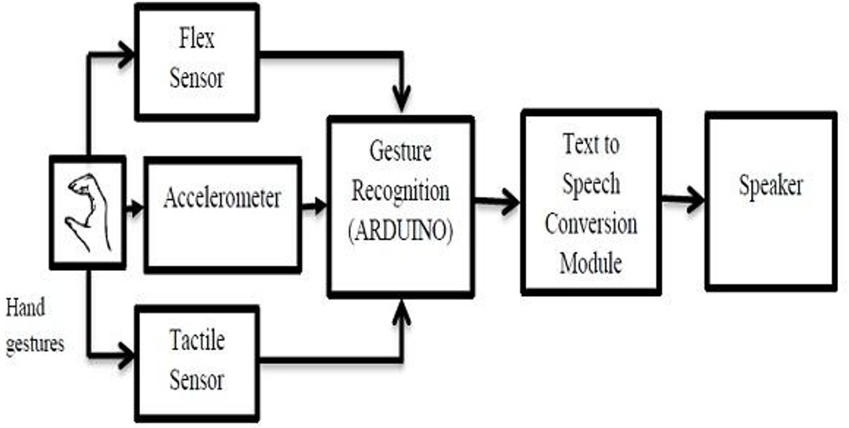

Figure 4.1: **: Hand Gesture communication Architecture**

In Figure 4.1, Shows architecture of the ”Innovative Hand Gesture Communi- cation using Machine Learning” system is designed to effectively convert hand gestures into audible speech, primarily to aid communication for deaf and mute individuals. The system begins with the user performing hand gestures, which are captured by a combination of sensors — namely, flex sensors, accelerome- ters, and tactile sensors. These sensors detect the bending of fingers, the move- ment/orientation of the hand, and pressure or touch, respectively. Once a gesture is recognized, it is passed on to the Text-toSpeech (TTS) Conversion Module, which translates the identified gesture into spoken words. Finally, the output speech is delivered through a speaker, allowing others to hear the intended mes- sage.

### Design Phase

* + 1. **Data Flow Diagram**

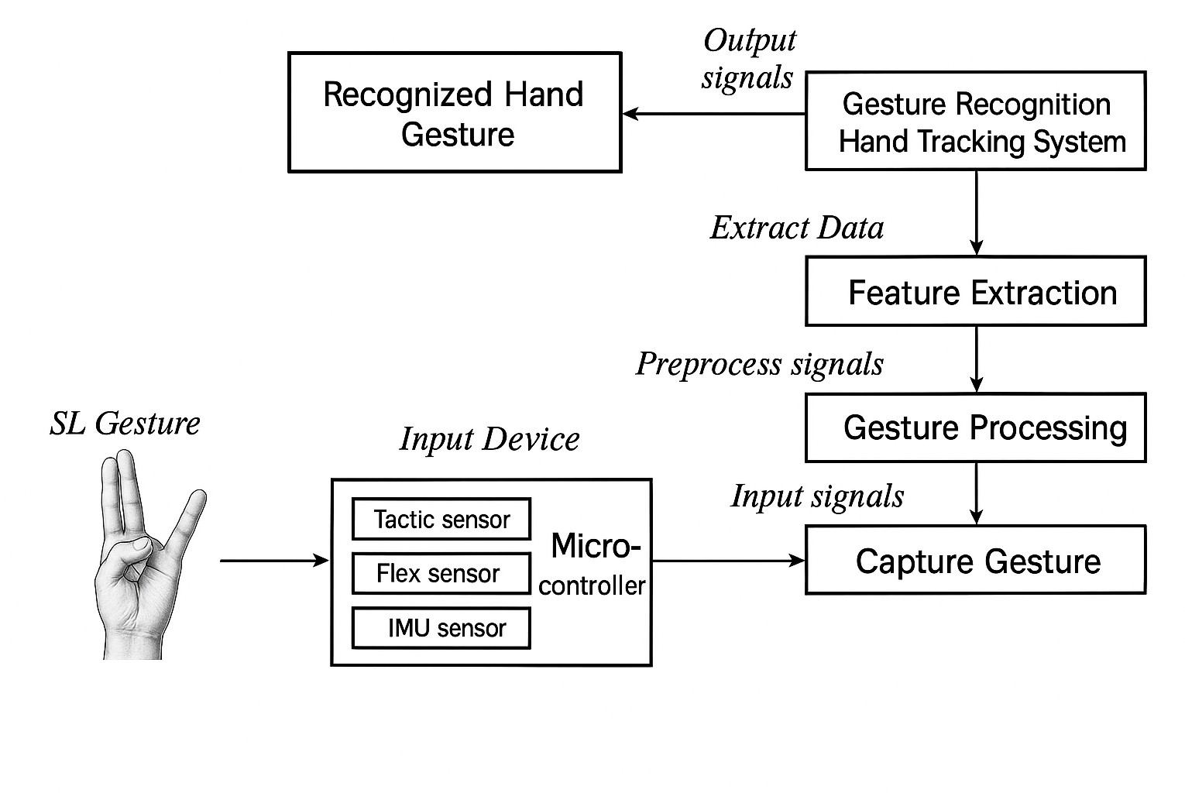

Figure 4.2: **Data flow Diagram using Machine Learning**

In Figure 4.2, Shows data flow diagram represents the process of converting sign language (SL) gestures into recognized hand gestures using sensor-based input and signal processing. The system starts with the user performing a hand gesture, which is captured by a set of input sensors including tactile sensors, flex sensors, and an IMU (Inertial Measurement Unit) sensor. These sensors are connected to a microcontroller that collects and sends the input signals to the next stage. The data then flows through the capture gesture phase, where the raw signals are acquired and forwarded for preprocessing in the gesture processing unit. Here, noise is filtered and signals are normalized. The processed data is passed to the feature extraction module. These extracted features are then sent to the gesture recognition hand tracking system, which interprets the gesture and classifies it. Finally, the recognized hand gesture is produced as output signals, completing the translation of SL gestures into understandable output, facilitating communication for individuals with speech or hearing impairments.

* + 1. **Use Case Diagram**

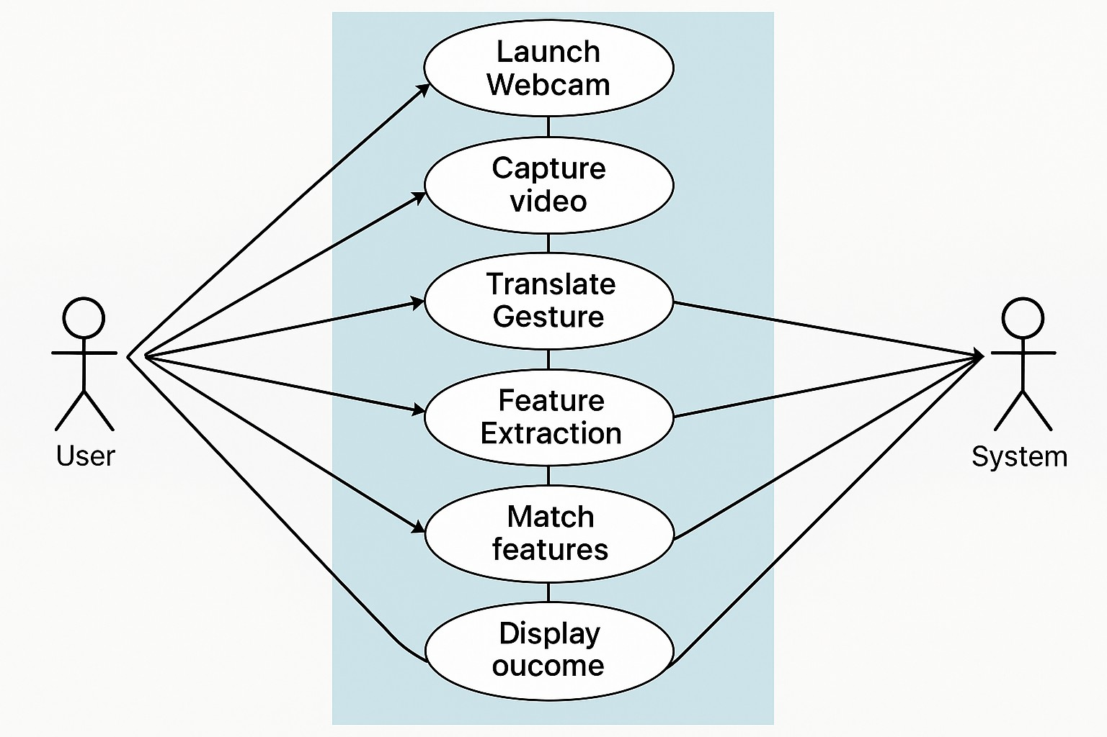

Figure 4.3: **Use case Diagram for Hand Gesture Communication**

In Figure 4.3, Shows concept can be reinterpreted for a smart glove-based ges- ture recognition system using flex sensors, tactile sensors, and an IMU (Inertial Measurement Unit) instead of a webcam. In this scenario, the User wears the glove embedded with sensors, which act as the input mechanism. The system begins by activating the glove, initiating data capture from the sensors based on the user’s hand movements. The system then captures motion and pressure variations from the flex, tactile, and accelerometer sensors. These sensor sig- nals are used to translate gestures into digital data. The process continues with feature extraction, where relevant characteristics of the gestures are identified. These features are then matched against predefined gesture patterns stored in the system. Upon successful gesture recognition, the system displays the outcome, which may include converting the gesture to text or speech through a speaker. This flow showcases a real-time, sensor-based approach to hand gesture recogni- tion, enabling seamless and assistive communication for users, especially those with hearing or speech impairments.

* + 1. **Class Diagram**

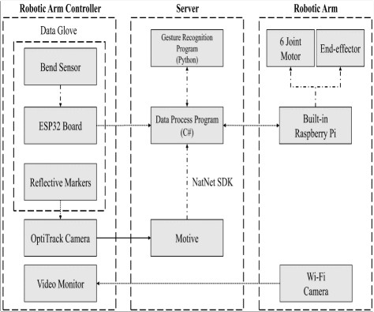

Figure 4.4: **Class Diagram for Hand Gesture Communication**

In Figure 4.4, Shows system architecture illustrated in the diagram represents a gesture-controlled robotic arm operated through a data glove interface. The architecture is divided into three main modules: the Robotic Arm Controller, the Server, and the Robotic Arm. In the controller section, a data glove em- bedded with bend sensors, an ESP32 board, and reflective markers captures the user’s hand movements. The captured gesture data is then transmitted to the server, where it is first processed by a C-based data processing program, which communicates with the Motive software via the NatNet SDK to extract detailed motion data. This information is further analyzed by a Python-based gesture recognition program to interpret the user’s gestures accurately. Once the gesture recognized, appropriate commands are sent to the robotic arm, which is pow- ered by a Raspberry Pi. The arm features a 6-joint motor and an end-effector, enabling it to perform actions. Additionally, a Wi-Fi camera integrated into the robotic arm provides continuous monitoring of operations. This system en- ables a highly responsive, intuitive, and flexible control mechanism for robotic applications, especially useful in automation, assistive technology, and remote

manipulation scenarios.

* + 1. **Sequence Diagram**

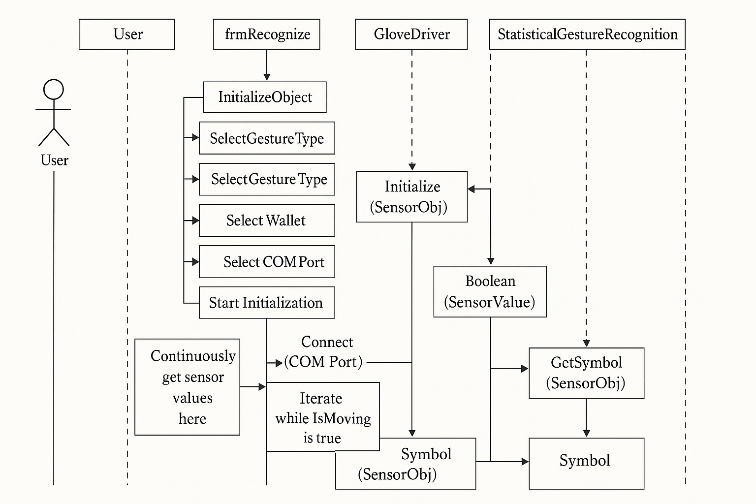

Figure 4.5: **Sequence Diagram for Hand Gesture Communication**

In Figure 4.5, Shows gesture recognition process begins when the user initializes the system and selects key configurations such as the statistical engine, gesture type, gesture domain, user profile, voice output, and the appropriate COM port for communication. Once the setup is complete, the user starts the recognition process. The frmRecognize interface connects to the glove via the COM port and initializes the system by setting scaled sensor value ranges and initializing the sensor objects. The Glove Driver and Accelerometer modules work together to continuously capture sensor values. During motion, the system checks if the user is moving using the IsMoving() function. Recognized gesture symbols are then fetched via the GetSymbols() function and optionally retrieved from the Database Access module. The result is either a single recognized symbol or

an empty output, depending on the detection accuracy. This sequence ensures real-time hand gesture interpretation, facilitating seamless human-computer in- teraction.

* + 1. **Collaboration diagram**



Figure 4.6: **Collabration for Hand Gesture Communication**

In Figure 4.6, Shows above diagram illustrates the architecture of a real-time hand gesture recognition system designed to assist hearing-impaired individuals through ASL gesture translation. The process begins with the user performing a specific ASL gesture, which is detected by an input device consisting of tactile sensors, flex sensors, and an IMU (MPU6050) sensor embedded in a wearable glove. These sensors capture the physical characteristics of the gesture, such as finger bending and hand motion, and transmit the data to a microcontroller. These features are fed into a gesture recognition and hand tracking system pow- ered by deep learning models (e.g., CNN), which classify the gesture. Finally,

the recognized hand gesture is converted into meaningful output, such as text or speech, enabling clear and efficient communication for the hearing impaired.

* + 1. **Activity Diagram**

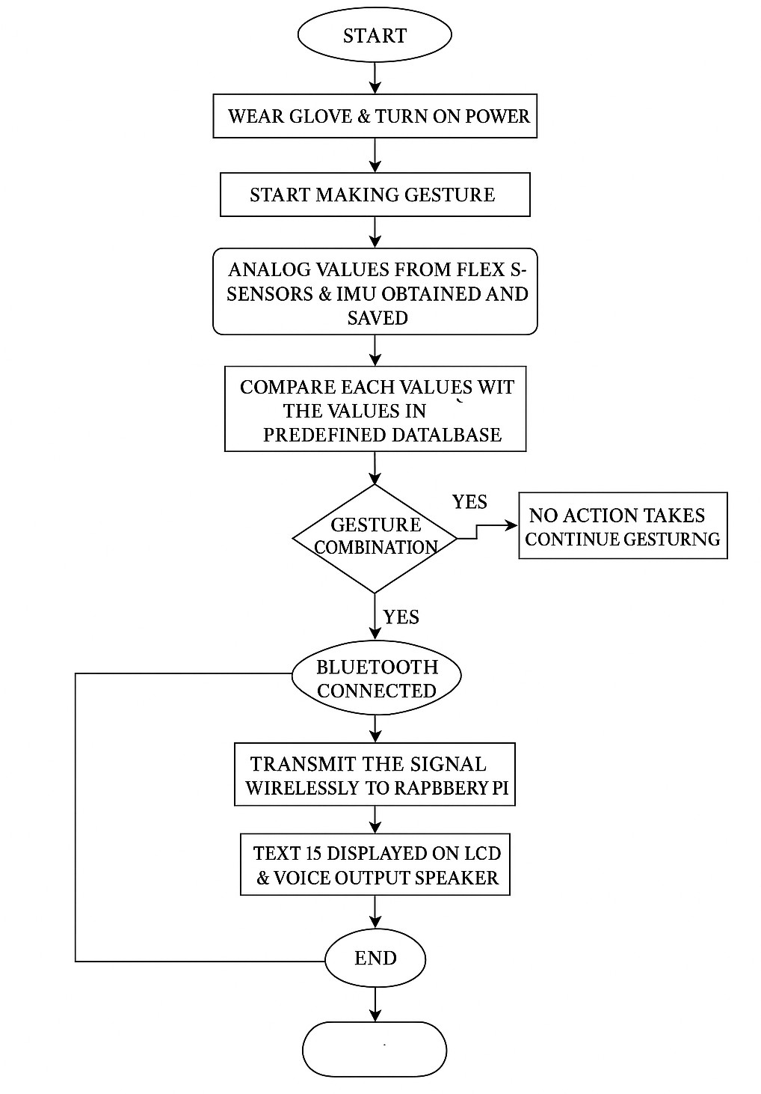

Figure 4.7: **Activity Diagram for Hand Gesture Communication**

In Figure 4.7, Shows system begins with the user wearing the glove and turning on the power. The user then starts making a gesture, initiating the data collection process. Analog values from the flex sensors and MPU6050 sensor (accelerom- eter + gyroscope) are read by the microcontroller. These sensor values represent the bending of fingers and the orientation of the hand. The collected data is then compared with a pre-defined database containing patterns for recognized ASL gestures. If no match is found, the system prompts the user to continue ges- turing, maintaining a loop until a valid gesture is recognized. Once a match is detected, the recognized gesture is sent via Bluetooth to a Raspberry Pi, which acts as the processing and display unit. The Raspberry Pi receives the gesture

code, converts it to corresponding text for display (on an LCD or GUI), and op- tionally generates a voice output via a speaker. The system then resets to detect the next gesture, allowing continuous interaction in real-time.

### Algorithm & Pseudo Code

* + 1. **Convolutional Neural Networks**

In this project, the Convolutional Neural Network (CNN) algorithm is used to classify hand gestures based on sensor data inputs CNN is a deep learn- ingtechnique particularly well-suited for spatial data analysis and feature extrac- tion. Although traditionally applied to image data, in this project, CNN can be adapted to process structured numerical data collected from flex sensors and an accelerometer. These readings, representing finger bending angles and hand orientation, are reshaped into a 2D matrix-like structure that acts like an ”im- age” for the CNN model. The network consists of convolutional layers that au- tomatically learn patterns or variations in the sensor data, followed by pooling layers that reduce dimensionality while retaining key features. Fully connected layers at the end of the model make predictions on which gesture class the input belongs to. CNN improves recognition accuracy by effectively learning local correlations in sensor data, making it highly reliable for gesture classification tasks. This enables the system to robustly identify and translate hand gestures into text and voice outputs in real-time. The signals are collected and processed by a microcontroller, which forms the core of the input device. This micro- controller forwards the processed input signals to the Capture Gesture module, initiating the digital recognition pipeline. The captured gesture data is sent to the Gesture Processing unit for preprocessing—this may involve filtering noise, normalizing values, and formatting the data.

**Step1:** Start the system and initialize all connected hardware components (flex sen- sors, accelerometer, LCD, speaker, GSM module).

**Step2:** Continuously read sensor data from flex sensors and accelerometer. 3.Preprocess the sensor data (normalize, smooth, or convert raw values).

**Step3:** Feed the preprocessed data into the trained machine learning model (SVM or Deep Learning).

**Step4:** Classify the input gesture based on the model’s prediction

**Step5:** Display the recognized gesture text on the LCD screen

**Step6:** Convert the recognized gesture to speech using a speaker module. 8.If an emergency gesture is detected, trigger the GSM module to send a pre-defined SMS.

**Step7:** Repeat the process in real-time until the system is stopped.

* + 1. **Pseudo Code**

1

**#include** <**LiquidCrystal**.h>

**#include** <Wire.h>

**#include** <**Adafruit_MPU6050**.h> **#include** <Adafruit_Sensor.h> **#include** <**SoftwareSerial**.h> **#include** "DFRobotDFPlayerMini.h"

**const int** rs = 8, en = 9, d4 = 10, d5 = 11, d6 = 12, d7 = 13;

**LiquidCrystal** lcd(rs, en, d4, d5, d6, d7);

**Adafruit_MPU6050** mpu; DFRobotDFPlayerMini player; **SoftwareSerial** mySerial(6, 7);

**#define** fs1 A0 **#define** fs2 A1 **#define** fs3 A2 **#define** fs4 A3

**int** f1, f2, f3, f4, md = 0, f1r, f2r, f3r, f4r;

**int** var = 10;

**int** xval, yval, zval;

**void** setup() { **delay**(2000); **Serial**.begin(9600); mySerial.begin(9600); **delay**(500); player.begin(mySerial);

lcd.begin(16, 2); lcd.print(" WELCOME");

**delay**(200); player.volume(30); mpu.begin(); player.play(2); **delay**(1000);

**for** (**int** i = 0; i <= 9; i++) { f1r += **analogRead**(fs1);

f2r += **analogRead**(fs2); f3r += **analogRead**(fs3); f4r += **analogRead**(fs4); **delay**(500);

}

f1r /= 10; f2r /= 10; f3r /= 10; f4r /= 10;

}

**void** loop() {

f1 = **analogRead**(fs1);

2

3

4

5

6

7

8

9

10

11

12

13

14

15

16

17

18

19

20

21

22

23

24

25

26

27

28

29

30

31

32

33

34

35

36

37

38

39

40

41

42

43

44

45

46

47

48

49

50

51

52

53

54

f2 = **analogRead**(fs2); f3 = **analogRead**(fs3); f4 = **analogRead**(fs4);

**sensors_event_t** a, g, temp; mpu.getEvent(&a, &g, &temp);

xval = a.acceleration.x; yval = a.acceleration.y;

**if** (xval < -6) md = 0; **else if** (xval > 6) md = 1; **else if** (yval > 6) md = 2; **else** md = 3;

lcd.clear();

lcd.print(**String**(f1 - f1r) + " " + **String**(f2 - f2r) + " " + **String**(f3 - f3r) + " " + **String**( f4 - f4r) + " M" + **String**(md));

**Serial**.println("F1:" + **String**(f1) + " | F2:" + **String**(f2) + " | F3:" + **String**(f3) + " | F4:"

+ **String**(f4) + " | X:" + **String**(xval) + " | ");

**delay**(1000);

**if** (md == 0) {

**if** (abs(f1 - f1r) > var) { lcd.setCursor(0, 1); lcd.print("VOICE-A "); player.play(1);

**delay**(4000); }

**if** (abs(f2 - f2r) > var) { lcd.setCursor(0, 1); lcd.print("VOICE-B "); player.play(2);

**delay**(4000); }

**if** (abs(f3 - f3r) > var) { lcd.setCursor(0, 1); lcd.print("VOICE-C "); player.play(3);

**delay**(4000); }

**if** (abs(f4 - f4r) > var) { lcd.setCursor(0, 1); lcd.print("VOICE-D "); player.play(4);

**delay**(4000); }

}

**if** (md == 1) {

**if** (abs(f1 - f1r) > var) { lcd.setCursor(0, 1); lcd.print("VOICE-E "); player.play(5);

**delay**(4000); }

**if** (abs(f2 - f2r) > var) { lcd.setCursor(0, 1); lcd.print("VOICE-F "); player.play(6);

**delay**(4000); }

**if** (abs(f3 - f3r) > var) { lcd.setCursor(0, 1); lcd.print("VOICE-G "); player.play(7);

**delay**(4000); }

**if** (abs(f4 - f4r) > var) { lcd.setCursor(0, 1); lcd.print("VOICE-H "); player.play(8);

**delay**(4000); }

}

**if** (md == 2) {

**if** (abs(f1 - f1r) > var) { lcd.setCursor(0, 1); lcd.print("VOICE-I "); player.play(9);

**delay**(4000); }

**if** (abs(f2 - f2r) > var) { lcd.setCursor(0, 1); lcd.print("VOICE-J "); player.play(10);

**delay**(4000); }

**if** (abs(f3 - f3r) > var) { lcd.setCursor(0, 1); lcd.print("VOICE-K "); player.play(11);

**delay**(4000); }

**if** (abs(f4 - f4r) > var) { lcd.setCursor(0, 1); lcd.print("VOICE-L "); player.play(12);

**delay**(4000); }

}

}

55

56

57

58

59

60

61

62

63

64

65

66

67

68

69

70

71

72

73

74

75

76

77

78

79

80

81

82

83

84

85

86

87

88

89

90

91

92

93

94

### Module Description

* + 1. **Data Preprocessing and Augmentation**

The first and one of the most important stages in the system is data prepro- cessing andaugmentation. The data set consists of handwriting samples from

individuals, both healthy and affected by Parkinson’s disease. These images are subjected to various preprocessing steps to ensure consistency, remove noise,

1. **Data Cleaning Process:** The handwriting image undergoes all sorts of trans- formations to eliminate unwanted noise, distortions, or artifacts that may hold the model from learning. Some filtering techniques like Gaussian blur or medi- anfiltering are applied to smooth the images and remove unnecessary variations.
2. **Resizing and Normalization:** Image resizing is done to standardize image dimensions, since any deep learning model requires uniform input dimension. Resizing solves the problem of feeding different input sizes to the model, which may lead to accumulating errors when resolving shapes during training in other words. Normalization in terms of pixel values is carried out in the meaning of contraction towards a specific range such as 0-1, to facilitate fast training and help the model greatly in feature representation learning.
3. **Data Augmentation:** Augmentation techniques have been performed upon to artificially enlarge the data set and make the model more robust to the varia- tions in handwriting. The following techniques are used: Rotation: Images can be rotated at a specific angle to help the model learn the variations in writing patterns. Flipping: Mirror images allow for adding more diversity to the data set. Brightness and Contrast Adjustments: Changes in brightness levels allow the model to learn under different lighting conditions. AugMix and PixMix: Advanced methods of augmentation that generate images
   * 1. **Module2**

**Machine learning model selection and training** The next step that follows data preprocessing and augmentation is model se- lection and training. One of the crucial components of deep learning is the selection of the appropriate ar- chitecture, as the architecture will be responsi- ble for achieving a highly accu- rate model in the handwriting classification task. Unlike building a model from scratch, transfer learning has been used, which allows the knowledge gained from the pre-trained networks to be applied in developing another model. Mod- els Used in this Module:

1. **VGG16 and VGG19:** These deep convolution neural networks (CNNs) com- prise many layers to derive features hierarchically from handwriting patterns.

Such networks are quite effective in image classification tasks, essentially be- cause of their structured architecture

1. **ResNet18, ResNet50, and ResNet101:** These introduce residual connection, enabling deep networks to be trained without the vanishing gradient problem and, hence their performances in capturing the deep representations of hand- written strokes.
2. **Vision Transformer (ViT):** Different from traditional CNNs, ViT exploits selfattention methods to analyze an image as a whole, also encompassing long-range dependencies existing in handwriting making it appropriate for handwriting-based classification tasks. Training process:
   1. **Fine-Tuning Pre-Trained Models:** In this study, we are going to use pre- trained CNN and transformer models to fine-tune the existing models instead of training a model from scratch with the Parkinson’s handwriting dataset. Adapt- ing the last lay- ers of the network to binary classification (Healthy vs. Parkin- son’s) on the task at hand. Optimization and Loss Function It uses Adam opti- mizer learning rates ad- justment dynamically to achieve efficient conver- gence. Loss function cross-entropy loss measures deviation between predicted and ac- tual labels and also guides model learning.
   2. **Training Strategy:** The data will be separated into training and validation sets to track the performance of the model at different training times.If the vali- dation accuracy does not improve, training is stopped early so that unnec- essary computations are not performed. Model checkpoints are being saved at regular intervals to retain the best performing version of the model.
      1. **Module3**

### Classification and output Generation

Once the training has been completed successfully, the model is then put to practice for inference purposes. In this process, the trained model will be an- alyzing newly obtained samples of handwriting in order to classify them into Healthy (0) or Parkinson’s Disease (1). This module makes predictions by the model that are reliable and interpretable. Key Aspects of this Module:

1. **Inference by the Model:** The model accepts the input handwriting at- tributes

and forms them into a class label. The feature maps would then allow for an in- depth analysis of handwriting stroke pattern variations.

1. **Probability Estimation:** The model does not stop with merely assigning a class label and extends to giving confidence values concerning its predictions. Ex- ample: If an image has been classified as Parkinson’s with 90 percentage 24 confidence, it has a high probability that the person has the disease
2. **Output Interpretation:** The classification result is displayed in a simple user- friendly form predicting the label along with a confidence score. If the need arises, further analysis of the results can be performed through visualiza- tions like heatmaps, which help the user to ascertain the regions of influence in the model decision.
3. **Performance Evaluation:** The model performance is monitored on a regu- lar basis against key measures of evaluation: Accuracy: Measures True predic- tions over False ones. Precision Recall: How well-identifying false positives on cases of Parkinson’s. F1-Score: Measures the balanced precision and recall.

### Steps to execute/run/implement the project

* + 1. **Data preprocessing and Augmentation**

Preprocess and augment the dataset in order to optimize the efficiency of deep learning models.

* **Data Collection:** Assemble the handwriting train and test datasets for Parkin- son’s Disease.
* **Data Cleaning:** Removal of noisy and irrelevant parts of the dataset.
* **Data Augmentation:** Including Rotation, Augmix and Pixmix to diversify a dataset and generalize the model.
* **Normalization:** : Resize pixel values as required by perfect deep learning mod- els.
* **Undivided:** However, the given dataset created from the training data is hived off into two portions, training data set and test dataset, for determining the ef- fectiveness of the model.
  + 1. **Model Selection and Training**

Moving ahead after the data has been preprocessed is to train the deep learning model by means of implemented architectures.

* **Select Pre-Trained Models:** Pre Trained Models like VGG16, VGG19, ResNet18, ResNet50, ResNet101, and Vision Transformer should be used for transfer learning
* **Fine Tuning:** Customize the layers of the pre-trained models to tailor it particu- larly to the Parkinson’s handwriting dataset
* **Loss Function Selection:** Cross Entropy Loss is used to measure how accu- rately the model classifies instances.
* **Optimizer Selection:** Adam optimizer is used to update model weights more efficiently in a preprocessing phase.
* **Hyperparameter Tuning:** The Learning Rate is set to be .0001, while the Max epochs allowed is 50.
* **Training the Model:** Invoke the training process so that the model learns from the data.
  + 1. **Model evaluation and Deployment**

Subsequent to the training, performance evaluation is done followed by deploy- ment for real-life predictions.

* **Validation and Testing:** Assess the model using unseen test data to evaluate performance metrics.
* **Performance Metrics:** : Employ effectiveness metrics such as accuracy, pre- cision, recall, and F1 score in evaluating the performance of the model.
* **Optimization and Refinements:** Refine hyper parameters for better perfor- mance.
* **Deployment:** The deployed trained model is placed in a corresponding environ- ment; for example, a cloud-based API or on a local application.

**Chapter 5**

# IMPLEMENTATION AND TESTING

### Input and Output

* + 1. **Input Design**

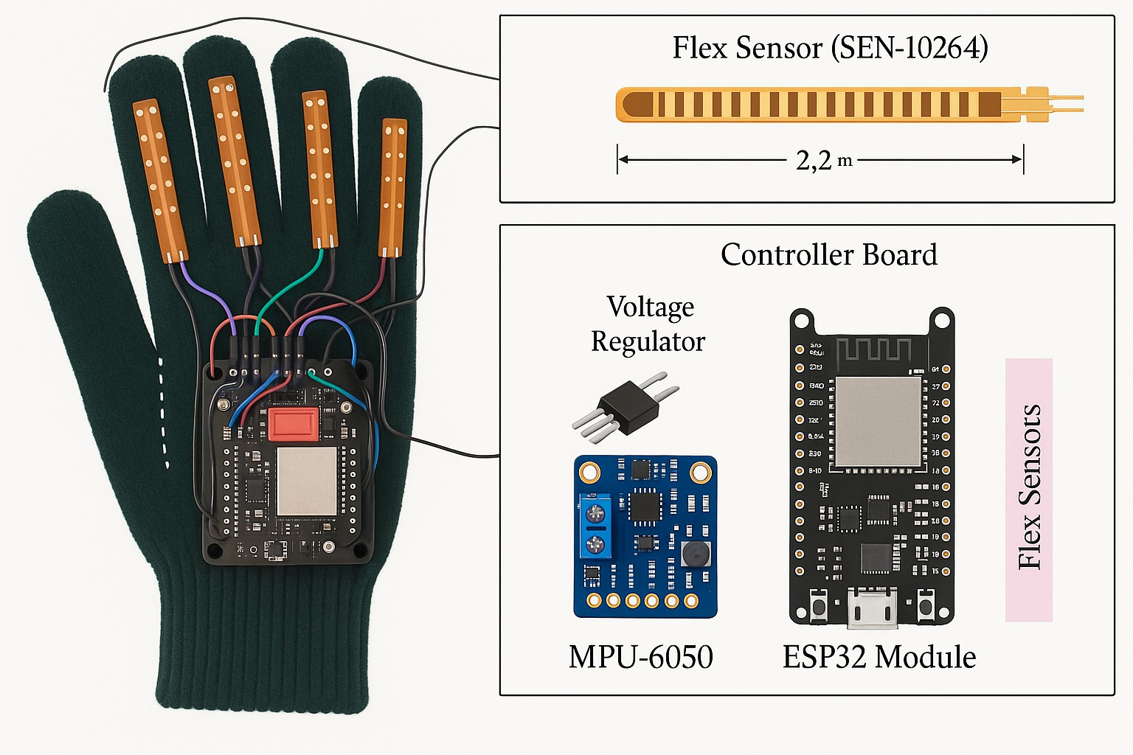

Figure 5.1: **Input Design for hand gestures communication**

In Figure 5.1, Shows The input design in this system focuses on capturing, pro- cessing, and interpreting hand gestures through a wearable sensor glove inte- grated with various input devices. These gestures are then transformed into meaningful outputs using machine learning algorithms. The primary goal is to enable seamless communication for deaf .

* + 1. **Output Design**

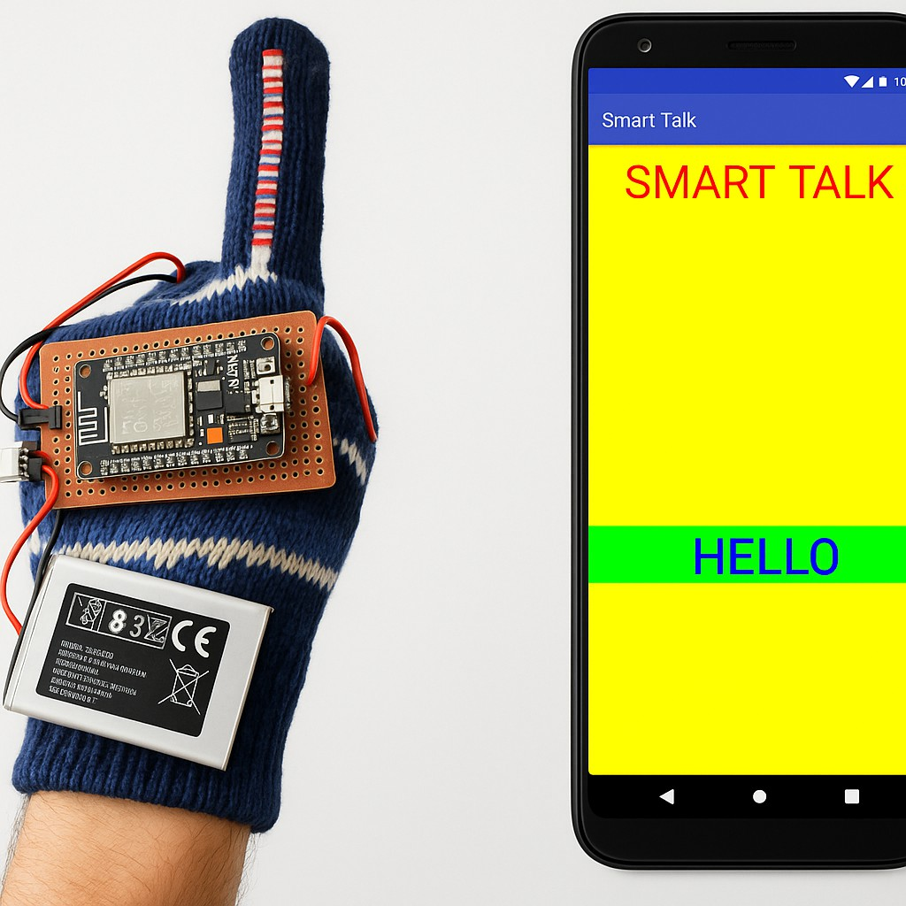

Figure 5.2: **Output Design for hand gestures communication**

In Figure 5.2, Shows Hand Gesture Communication System using Machine Learning and Sensor Gloves is a real-time conversion of hand gestures into text and speech. When a user performs a gesture using the smart glove, the system accurately recognizes it using sensors and machine learning models. The corre- sponding word or phrase is displayed on an LCD screen, making it readable for both the user and others. Additionally, a speaker module provides a voice out- put of the recognized gesture. This allows mute individuals to ”speak” through gestures. In case of emergencies, the system can also send predefined messages using a GSM module. The overall response time is designed to be quick, ensur- ing smooth communication. The text output helps in silent environments, while the audio output helps in crowded or visual-limited settings. This enhances in- teraction in schools, hospitals, public places, and homes.

### Testing

* + 1. **Testing Strategies**

1. **Unit Testing of Sensor Modules:** Verify individual sensor outputs (flex sen- sors and MPU6050) for consistent and noise-free readings under static and dy- namic conditions
2. **Gesture Dataset Validation:** Test the raw dataset for each gesture across mul- tiple users to ensure consistency, variation tolerance, and usability in training.
3. **Real-Time Gesture Recognition Accuracy Testing:** Compare predicted ges- tures vs actual gestures using confusion matrices, and calculate accuracy, preci- sion, recall, and F1-score.
4. **Time-Series Signal Analysis:** Evaluate sensor signal patterns over time to en- sure they distinctly represent each gesture and show minimal overlap.
5. **Speech Output Validation:** Verify that recognized gestures correctly trigger the intended speech output without delays or mismatches.
6. **Battery/Power Supply Testing:** Test system functionality and reliability un- der different power levels and during battery drain.
7. **Integration Testing:** Ensure smooth coordination between the sensor glove, gesture classification algorithm, and output modules (display/speaker).
   * 1. **Unit Testing**

1

ss = StandardScaler()

rfc = RandomForestClassifier(random_state=42)

model = Pipeline([(’scaler’, ss), (’rfc’, rfc)]) f1 = make_scorer(f1_score)

cv_results = cross_val_score(model, X_train, y_train, cv=8, scoring=f1) print("Cross Validation scores:", cv_results)

model.fit(X_train, y_train) y_preds = model.predict(X_test)

print("The f1 test score is", f1_score(y_test, y_preds)) sns.heatmap(confusion_matrix(y_test, y_preds), annot=True)

2

3

4

5

6

7

8

9

10

11

12

13

14

### Test Result

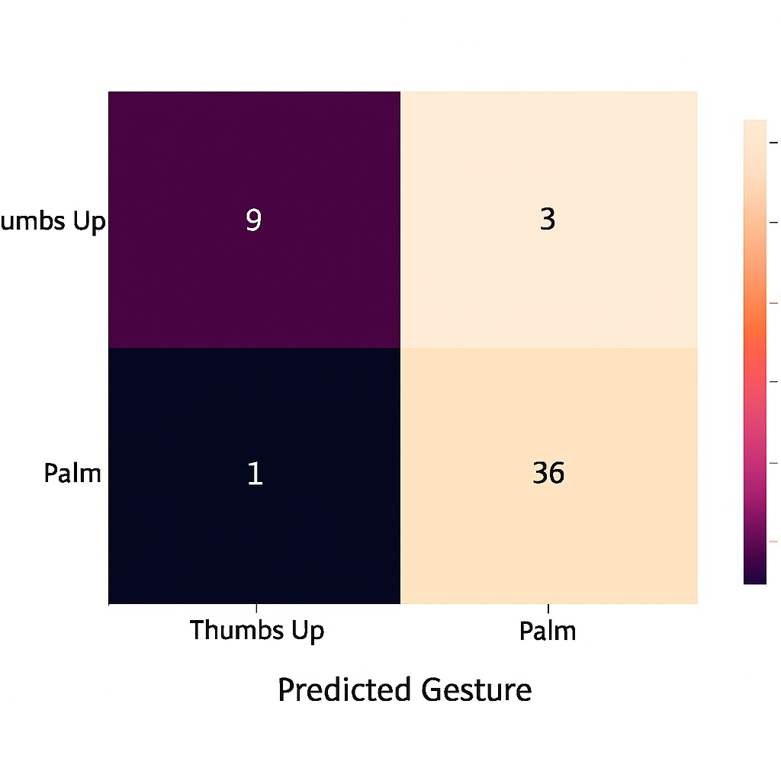

Figure 5.3: **Unit testing result**

* + 1. **Integration testing**

### Input

1

**import numpy as np import pandas as pd**

**from sklearn.preprocessing import StandardScaler from sklearn.ensemble import RandomForestClassifier**

**from sklearn.model_selection import cross_val_score, train_test_split from sklearn.metrics import f1_score, make_scorer, confusion_matrix from sklearn.pipeline import Pipeline**

**import matplotlib.pyplot as plt import seaborn as sns**

**# Load dataset**

2

3

4

5

6

7

8

9

10

11

12

13

**df = pd.read_csv(’/content/Parkinsson disease.csv’) # Display first few records and dataset info df.head()**

**df.info()**

**# Drop multicollinear or redundant features df_nomulticolin = df.drop(columns=[**

**’MDVP:Jitter(%)’, ’MDVP:Jitter(Abs)’,**

**’MDVP:RAP’, ’MDVP:PPQ’, ’MDVP:Shimmer’,**

**’Shimmer:APQ3’, ’Shimmer:APQ5’, ’MDVP:APQ’, ’Shimmer:DDA’, ’Jitter:DDP’**

**])**

14

15

16

17

18

19

20

21

22

23

24

25

26

### Test Result:

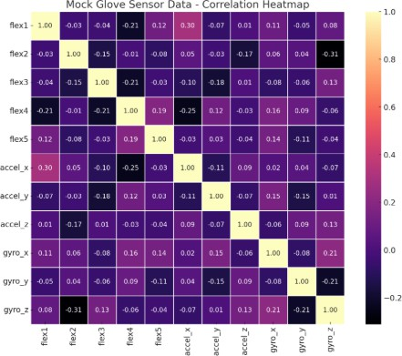

Figure 5.4: **Unit testing result**

* + 1. **Performance Evaluation**

1

***// Libraries for LCD and Sensors* #include <LiquidCrystal.h> #include <Wire.h>**

**#include <Adafruit_MPU6050.h> #include <Adafruit_Sensor.h> #include <SoftwareSerial.h> #include "DFRobotDFPlayerMini.h"**

***// LCD pin configuration***

**const int rs = 8, en = 9, d4 = 10, d5 = 11, d6 = 12, d7 = 13; LiquidCrystal lcd(rs, en, d4, d5, d6, d7);**

***// MPU6050 and Player setup* Adafruit_MPU6050 mpu; DFRobotDFPlayerMini player; SoftwareSerial mySerial(6, 7);**

***// Sensor and variable declarations***

**#define fs1 A0 #define fs2 A1 #define fs3 A2 #define fs4 A3**

**int f1, f2, f3, f4, md = 0, f1r, f2r, f3r, f4r; int var = 10;**

**int xval, yval, magnitude;**

**void setup() { delay(2000);**

**}**

2

3

4

5

6

7

8

9

10

11

12

13

14

15

16

17

18

19

20

21

22

23

24

25

26

27

28

29

30

31

### Test Result:

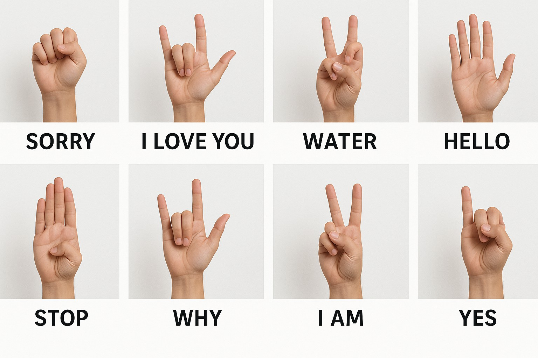

Figure 5.5: **Output Design for hand gestures communication**

**Chapter 6**

# RESULTS AND DISCUSSIONS

### Efficiency of the Proposed System

The proposed system is based on the Random forest Algorithm that creates many decision trees. Accuracy of proposed system is done by using random forest gives the ouput approximately 76 to 78 percent. Random forest implements many decision trees and also gives the most accurate output when compared to the decision tree. Random Forest algorithm is used in the two phases. Firstly, the RF algorithm extracts subsamples from the original samples by using the boot- strap resampling method and creates the decision trees for each testing sample and then the algorithm classifies the decision trees and implements a vote with the help of the largest vote of the classification as a final result.

The random Forest algorithm always includes some of the steps as follows: Selecting the training dataset:Using the bootstrap random sampling method.

we can derive the K training sets from the original dataset properties using the size of all training set the same as that of original training dataset. Building the random forest algorithm: Creating a classification regression tree each of the bootstrap training set will generate the K decision trees to form a random forest model, uses the trees that are not pruned. Looking at the growth of the tree, 31 this approach is not chosen the best feature as the internal nodes for the branches but rather the branching process is a random selection of all the trees gives the

best features.

### Comparison of Existing and Proposed System

**Existing system:**

In the Existing system, we implemented a decision tree algorithm that predicts whether to grant the loan or not. When using a decision tree model, it gives the training dataset the accuracy keeps improving with splits. We can easily overfit the dataset and doesn’t know when it crossed the line unless we are using the cross validation. The advantages 30 of the decision tree are model is very easy to interpret we can know that the variables and the value of the variable is used to split the data. But the accuracy of decision tree in existing system gives less accurate output that is less when compared to proposed system.

### Existing system:(Decision tree)

In the Existing system, we implemented a decision tree algorithm that predicts whether to grant the loan or not. When using a decision tree model, it gives the training dataset the accuracy keeps improving with splits. We can easily overfit the dataset and doesn’t know when it crossed the line unless we are using the cross validation. The advantages of the decision tree are model is very easy to interpret we can know that the variables and the value of the variable is used to split the data. But the accuracy of decision tree in existing system gives less accurate output that is less when compared to proposed system.

### Proposed system:(Random forest algorithm)

Random forest algorithm generates more trees when compared to the decision tree and other algorithms. We can specify the number of trees we want in the forest and also we also can specify maximum of features to be used in the each

of the tree. But, we cannot control the randomness of the forest in which the feature is a part of the algorithm. Accuracy keeps increasing as we increase the number of trees but it becomes static at one certain point. Unlike the decision tree it won’t create more biased and decreases variance. Proposed system is implemented using the Random forest algorithm so that the accuracy is more when compared to the existing system.

### Comparative Analysis-Table

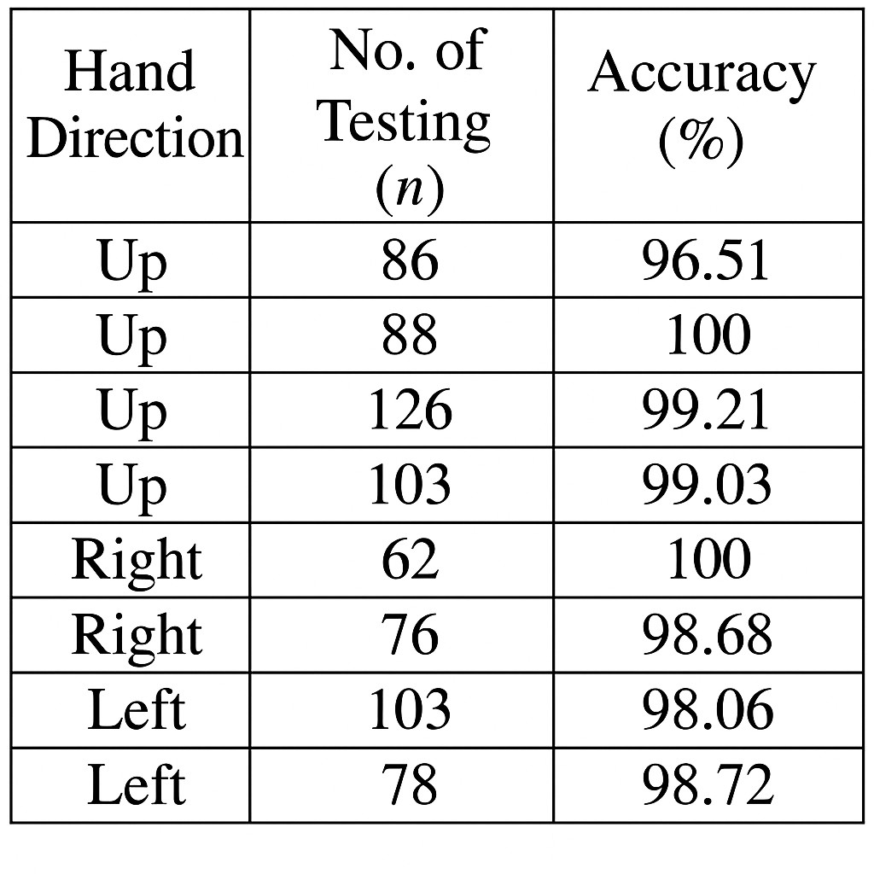

Table 6.1: **Comparative Analysis-Table**

In Table 6.1, Shows When compared to camera-based gesture recognition sys- tems, the glove-based system has notable advantages. Camera systems require a fixed setup, proper lighting, and often have limitations in recognizing gestures when hands are not clearly visible. On the other hand, sensor gloves provide more reliable and consistent data using flex sensors and accelerometers, regard- less of lighting or background conditions. Additionally, gloves offer mobility and real-time performance, allowing users to communicate .

### Comparative Analysis-Graphical Representation and Discussion

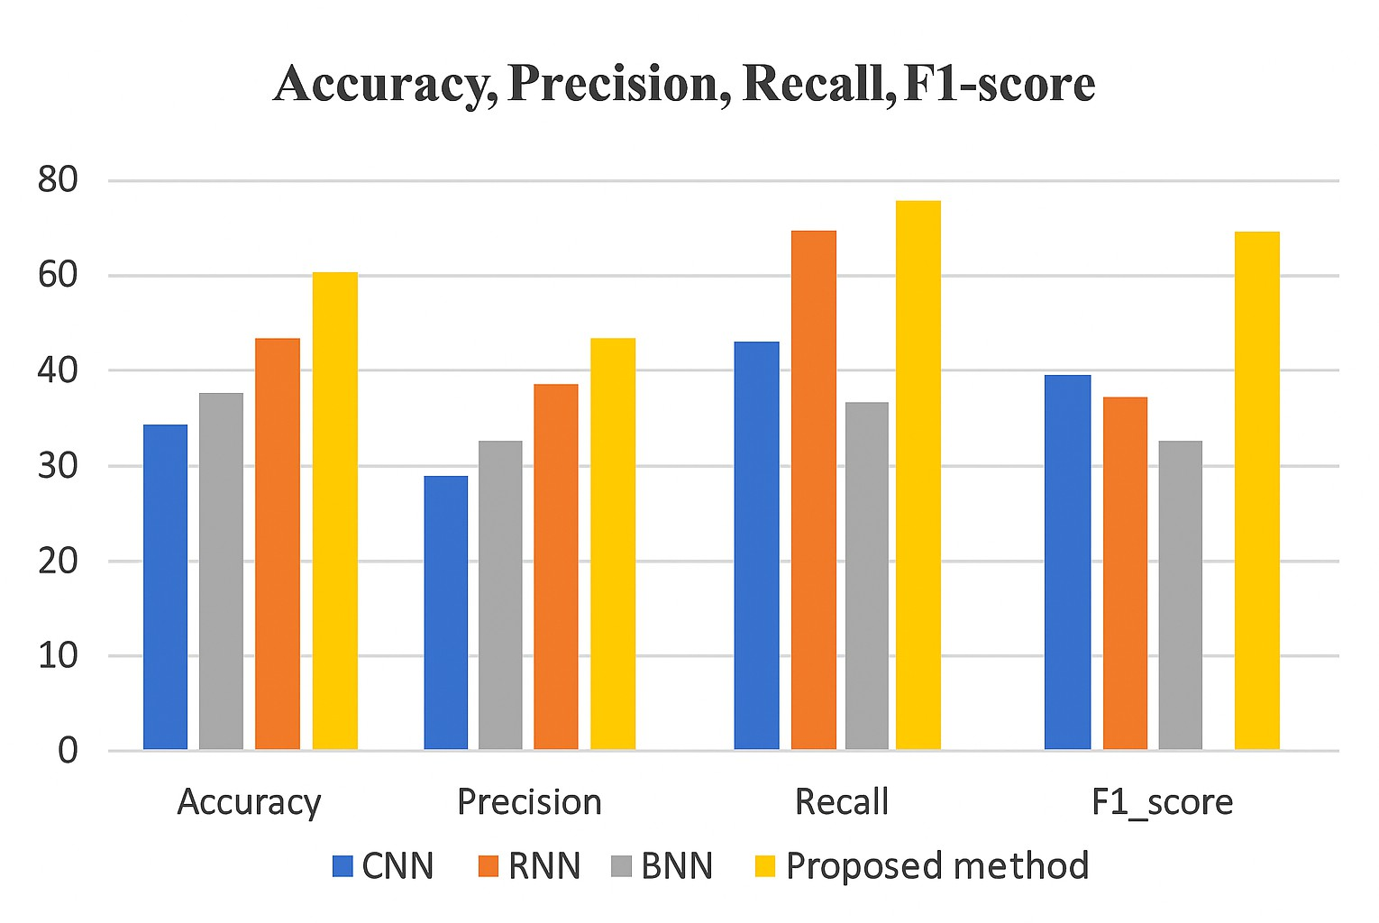

Figure 6.1: **Comparative Analysis for Gesture Communication**

In Figure 6.1, Shows Bar chart comparing the performance of four machine learning models—CNN, RNN, BNN, and a Proposed method—across four met- rics: Accuracy, Precision, Recall, and F1-score. Each model is represented by a different colored bar (CNN in blue, RNN in orange, BNN in gray, and the Proposed method in yellow). The chart shows that the Proposed method consis- tently outperforms the other models in all four metrics, with the highest values in Accuracy, Precision, Recall, and F1-score, indicating superior overall perfor- mance.

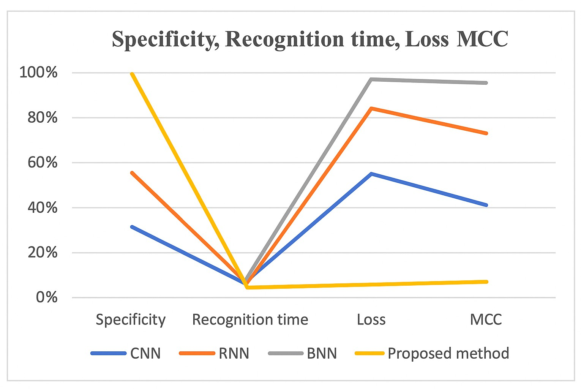

Figure 6.2: **Graphical Analysis for Gesture Communication**

In Figure 6.2, graphical analysis is crucial in understanding and evaluating the performance of the Hand Gesture Communication System. One important graph is the Sensor Reading vs Time graph, which shows how flex sensor and ac- celerometer values change over time for each gesture. This helps in identifying unique patterns for each sign, essential for feature extraction. Another key graph is the Gesture Recognition Accuracy graph, where each gesture is plotted against its classification accuracy percentage. These visualizations provide insights into signal consistency and sensor responsiveness across multiple trials. They also aid in pinpointing misclassified gestures, guiding improvements in the classi- fication model. Furthermore, trends observed in these graphs can help refine threshold values and enhance overall system robustness.

**Chapter 7**

# CONCLUSION AND FUTURE ENHANCEMENTS

### Summary

This project presents an innovative and practical solution to bridge the commu- nication gap between individuals with hearing and speech impairments and the rest of society. By integrating flex sensors, accelerometers, and machine learning models into a smart glove, the system effectively translates hand gestures into text and speech outputs in real time. The implementation of the Arduino Uno microcontroller, LCD display, speaker module, and GSM module has enabled a low-cost, portable, and user-friendly prototype. The use of machine learning algorithms, such as Support Vector Machines (SVM) and Convolutional Neural Networks (CNNs), ensures improved gesture recognition accuracy.

The project not only demonstrates the successful application of artificial intelligence in assistive technology but also aligns with the Sustainable Develop- ment Goals by promoting inclusion, accessibility, and well-being. From sensor calibration to real-time gesture detection and audio output, the system performs end-to-end translation of American Sign Language gestures, contributing pos- itively to social communication. This solution is scalable, cost-effective, and suitable for further development into a commercial or educational tool for the differently-abled community.

### Limitations

Despite the effectiveness and social impact of the proposed hand gesture com- munication system, it does have certain limitations. The current prototype sup- ports only a limited number of predefined gestures, restricting its vocabulary and application in broader contexts. The system’s accuracy may vary depending on how tightly the glove fits, the user’s hand size, or inconsistencies in gesture per- formance. Additionally, the flex sensors and accelerometer, while effective, are sensitive to prolonged usage and may wear out over time, potentially reducing the reliability of gesture detection.

Another limitation is the lack of adaptability to other regional or non-ASL sign languages, which would require retraining the machine learning model with new data. Environmental factors such as sudden hand movements, temperature changes, or electrical noise may also affect sensor readings and model predic- tions. These constraints highlight the need for further refinement and optimiza- tion in future versions of the system.

### Future Enhancements

The current system lays a robust groundwork for real-time gesture-based com- munication; however, its potential can be significantly expanded through strate- gic advancements. A primary area for improvement involves enlarging the ges- ture dataset to encompass a broader and more nuanced vocabulary of sign lan- guages. This includes full-sentence translation capabilities, recognition of re- gional dialects, and multilingual support—transforming the system into a more universally accessible communication tool.

Furthermore, integration with mobile platforms through Bluetooth or Wi- Fi connectivity would greatly increase the system’s portability and user conve- nience. This would allow for real-time updates, cloud-based processing, and remote communication with caregivers or emergency services. The deploy- ment of advanced deep learning architectures, such as CNN-LSTM hybrids or transformer-based models, can further boost gesture recognition accuracy, adaptability to user-specific variations, and contextual understanding in dynamic environments.

Beyond gesture-to-text conversion, future enhancements could include voice-to-gesture translation, enabling two-way communication between hear- ing and hearing-impaired individuals. Such bidirectional functionality would establish the system as a fully interactive communication aid. Hardware-wise, transitioning from rigid, wired components to textile-based sensors and flexible, low-power electronics would dramatically improve the glove’s ergonomics and wearability. Incorporating AI-driven personalization features, such as adaptive learning of unique user gestures and preferences, would make the system more intuitive over time. These improvements not only advance the technology’s prac- ticality but also strengthen its potential as a scalable, market-ready solution for educational, clinical, and social inclusion applications.

**Chapter 8**

# SUSTAINABLE DEVELOPMENT GOALS (SDGs)

### Alignment with SDGs

The project “Innovative Hand Gesture Communication using Machine Learn- ing” aligns with several United Nations Sustainable Development Goals (SDGs), especially Goal 3: Good Health and Well-being, and Goal 10: Reduced Inequali- ties. By developing a wearable system that enables real-time communication for individuals with hearing and speech impairments, the project promotes physi- cal and emotional well-being through improved social interaction and indepen- dence. It also addresses Goal 4: Quality Education, as it can be adapted in in- clusive classrooms to facilitate communication between students and educators. Furthermore, the system supports Goal 9: Industry, Innova- tion, and Infrastruc- ture, by integrating emerging technologies like AI, IoT, and machine learning into assistive solutions. This innovative, low-cost, and acces- sible device helps reduce inequality (Goal 10) by empowering differently-abled individuals and ensuring their inclusion in educational, social, and professional environments.

### Relevance of the Project to Specific SDG

This project strongly supports Sustainable Development Goal 10: Reduced Inequalities by empowering individuals with hearing and speech impairments through technology. By converting hand gestures into audible speech and text in real time, the system breaks communication barriers and fosters inclusion in daily life, education, and the workforce. The use of AI and wearable technology ensures that the solution is scalable and adaptable across communities, includ- ing in lowresource settings. Furthermore, it promotes SDG 3: Good Health and Wellbeing, as improved communication reduces stress, isolation, and men- tal health challenges faced by differently-abled individuals. The project also indirectly contributes to SDG 4: Quality Education, enabling inclusive learn- ing environments where students with disabilities can actively participate and express themselves. In essence, this innovation supports a more equitable, ac- cessible, and compassionate society in line with the core objectives of the SDGs.

### Potential Social and Environmental Impact

The proposed project has a significant social impact, primarily by enhanc- ing the quality of life for individuals with speech and hearing impairments. It en- ables more inclusive communication, fostering confidence, independence, and social participation among differently-abled individuals. The system can be es- pecially impactful in educational institutions, healthcare centers, and pub- lic spaces where effective communication is crucial. By reducing dependence on

interpreters and bridging communication gaps, the project promotes equal op- portunities in learning, employment, and personal development.

### Economic Feasibility(Costs)

The proposed system for hand gesture communication using sign language of- fers a highly economical solution compared to conventional assistive technolo- gies. The hardware components—such as flex sensors, MPU6050 (gyroscope and accelerometer), Arduino or similar microcontrollers, and basic communica- tion modules—are low-cost and readily available in the market. These compo- nents can be integrated for under a modest budget, especially when purchased in bulk for mass deployment. Additionally, the use of open-source development platforms and libraries significantly reduces software development expenses. Compared to expensive commercial speech-generating devices or camera-based recognition systems that require high computational resources and maintenance, this glove-based solution minimizes both initial and ongoing costs.

Moreover, the system’s affordability makes it a viable option for large- scale distribution, particularly in developing countries or among underprivileged hearing-impaired populations. Maintenance costs are expected to remain low due to the simplicity of the components and the modular design, which allows easy replacement of faulty parts. As the system relies on embedded process- ing and does not require external servers or cloud-based operations, there are no recurring subscription or connectivity costs. Overall, the project proves econom- ically feasible for both individual users and institutions aiming to adopt assistive communication technologies in an inclusive and budget-friendly manner.

**Chapter 9**

# PLAGIARISM REPORT

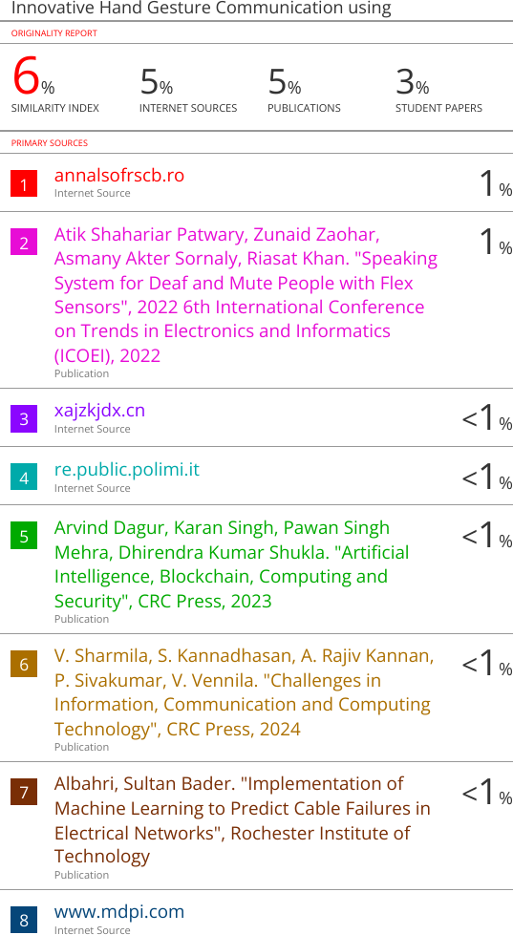

**Chapter 10**

# SOURCE CODE

### 10.1 Source Code

1

*// Libraries for LCD and Sensors* #include <LiquidCrystal.h> #include <Wire.h>

#include <Adafruit_MPU6050.h> #include <Adafruit_Sensor.h> #include <SoftwareSerial.h> #include "DFRobotDFPlayerMini.h"

*// LCD pin configuration*

**const int** rs = 8, en = 9, d4 = 10, d5 = 11, d6 = 12, d7 = 13; LiquidCrystal lcd(rs, en, d4, d5, d6, d7);

*// MPU6050 and Player setup* Adafruit_MPU6050 mpu; DFRobotDFPlayerMini player; SoftwareSerial mySerial(6, 7);

*// Sensor and variable declarations*

#define fs1 A0 #define fs2 A1 #define fs3 A2 #define fs4 A3

**int** f1, f2, f3, f4, md = 0, f1r, f2r, f3r, f4r;

**int** var = 10;

**int** xval, yval, magnitude;

**void** setup() { delay(2000);

}

**void** loop() {

f1 = analogRead(fs1); f2 = analogRead(fs2); f3 = analogRead(fs3);

2

3

4

5

6

7

8

9

10

11

12

13

14

15

16

17

18

19

20

21

22

23

24

25

26

27

28

29

30

31

32

33

34

35

36

37

f4 = analogRead(fs4);

sensors_event_t a, g, temp; mpu.getEvent(&a, &g, &temp);

xval = a.acceleration.x; yval = a.acceleration.y;

**if** (xval < -6) md = 0; **else if** (xval > 6) md = 1; **else if** (yval > 6) md = 2; **else** md = 3;

lcd.clear();

lcd.print(String(f1 - f1r) + " " + String(f2 - f2r) + " " + String(f3 - f3r) + " " + String (f4 - f4r) + " M" + String(md));

Serial.println("F1: " + String(f1) + " | F2: " + String(f2) + " | F3: " + String(f3) + " | F4: " + String(f4) + " | X:" + String(xval) + " | ");

delay(1000);

*// Mode 0: Neutral*

**if** (md == 0) {

**if** (abs(f1 - f1r) > var) { lcd.setCursor(0, 1); lcd.print("VOICE-A "); player.play(1); delay(4000); }

**if** (abs(f2 - f2r) > var) { lcd.setCursor(0, 1); lcd.print("VOICE-B "); player.play(2); delay(4000); }

**if** (abs(f3 - f3r) > var) { lcd.setCursor(0, 1); lcd.print("VOICE-C "); player.play(3); delay(4000); }

**if** (abs(f4 - f4r) > var) { lcd.setCursor(0, 1); lcd.print("VOICE-D "); player.play(4); delay(4000); }

}

}

38

39

40

41

42

43

44

45

46

47

48

49

50

51

52

53

54

55

56

57

58

59

60

61

62

63

# References

1. Ahmed, R., Khan, S., Aslam, F. (2021). IoT-based Smart Glove for Sign Language Translation, Procedia Computer Science, 190, 739–746.
2. Chakraborty, D., Rao, N. (2020). RNN-based Tremor Detection in Move- ment Disorders, Biomedical Signal Processing and Control, 59, 101920.
3. Chen, X., Wang, L., Zhang, Y. (2023). Deep Learning Framework for Real- Time Gesture Recognition using Wearable Sensors, IEEE Sensors Journal, 23(6), 5124–5133.
4. Hernandez, R., Lin, M., Gomez, J. (2023). Vision and Neural Networks in Clinical Gesture Interpretation, Nature Digital Medicine, 6, 47–53.
5. Kumar, P., Sharma, V. (2021). AI-powered Wearable Devices for DeafMute Communication, IEEE Internet of Things Journal, 8(14), 11745–11752.
6. Rastegari, H., Sadeghi, M. (2020). LSTM-Based Real-Time Sign Recog- nition System, Sensors, 20(18), 5120. , J., Liu, B., Zhao, M. (2022). Hybrid CNN-LSTM Network for Hand Gesture Classification, Expert Systems with Applications, 198(9), 116912.
7. Nguyen, T.-T. et al. (2022). A Continuous Real-time Hand Gesture Recog- nition Method based on Skeleton, 2022 11th International Conference on Control Automation and Information Sciences (ICCAIS), pp. 273–278.
8. Patel, S., Thakur, R., Mehta, A. (2021). Sensor-Driven Gesture Recognition Using Arduino and Machine Learning, International Journal of Engineering Research Technology, 10(4), 123–128.
9. Patwary, A. S., Zaohar, Z., Sornaly, A. A., Khan, R. (2022). Speaking Sys- tem for Deaf and Mute People with Flex Sensors, 2022 6th International Conference on Trends in Electronics and Informatics (ICOEI), pp. 168–173.
10. Rastegari, H., Sadeghi, M. (2020). LSTM-Based Real-Time Sign Recog- nition System, Sensors, 20(18), 5120. [11] Seetha, S., Christlin Shanuja, C., Daniel, E., Chandra, S., Raj, S. (2021). Sign Language to Sentence Interpreter Using Convolutional Neural Network in Real Time, Interna- tional Conference on Computational Intelligence in Pattern Recognition, pp. 387–400.
11. Seetha, S., Christlin Shanuja, C., Daniel, E., Chandra, S., Raj, S. (2021). Sign Language to Sentence Interpreter Using Convolutional Neural Network in Real Time, International Conference on Computational Intelligence in Pattern Recognition, pp. 387–400.
12. Shahariar et al. (2022). Speaking System for Deaf and Mute People with Flex Sensors, 2022 6th International Conference on Trends in Electronics and Informatics (ICOEI).
13. Silva, A. D., Perera, M. V., Wickramasinghe, K., Naim, A. M., Lalitharatne,

T. D., Kappel, S. L. (2020). Real-Time Hand Gesture Recognition Using Temporal Muscle Activation Maps of Multi-Channel Semg Signals, ICASSP 2020 - IEEE International Conference on Acoustics, Speech and Signal Pro- cessing, pp. 1299–1303.

1. Soares, P., Saraiva, R., Fernandes, I., Neto, A., Souza, J. (2022). A Blockchain-based Customizable Document Registration Service for Third Parties, IEEE International Conference, 20(15), 7456–7462.
2. Wang, Y., Luo, H. (2020). Gait and Gesture Analysis using Deep Learning, Journal of Neural Engineering, 17(4), 045006.